STUDENT GUIDE TO THE HOUSE RULES
Including Under 18 and Study Tour Guidelines
Welcome to Australia! We hope you enjoy your stay. Below are guidelines, which will help to create a happy home for everyone.

Write these details down and keep them on you in case of an  emergency | Telephone numbers  AHN 24 hour = 1300 MYSTAY - 1300 697829  Police/Fire/Ambulance Emergency: 000  Host Name: ____________________________________________________  Address: ____________________________________________________  _________________________________________________________________  Home Phone: ____________________________________________________  Mobile: ____________________________________________________  Email: ____________________________________________________
Contacting you in Australia:
- Between you and your family: Please use your mobile phone or purchase a pre-paid phone card.
- Between you and AHN/your host: You need to advise your email address as soon as you arrive and your mobile as soon you have set it up.
Payments for your stay:
- Homestay invoices are sent to you via email and can be viewed in the AHN system.
- If you have forgotten your login details, please reset your password via this link: https://au.homestaynetwork.org/users/forgot_password
- Payment Reference - Please use your GUEST ID as your payment reference so that AHN can match your payment to your invoice
Health Issues
- Tell your host if you are feeling unwell. They’ll advise you where the nearest medical centre is.
- You may have to pay to see the doctor, however your OSHC may cover some medical costs. Dental and optical are not covered under your health insurance. You will receive your health care card on orientation day at your school.
- 13SICK is the number for medical assistance after 6:00pm at night and before 6:00am in the morning.
- Follow any public health directions in your local area, and check to see if there are any public health orders in place when travelling away from your homestay.
- If you are having a challenging time, it's OK to seek help and support. You can reach out to the below organisations for assistance.
All Ages
- Beyond Blue 1300 224 636
- Lifeline Australia 13 11 14
Lifeline also offers a free interpreting service. To access this service:
1) Call TIS National on 131 450 and ask to talk to Lifeline on 13 11 14 in the language required.
2) TIS National will call 13 11 14 on your behalf.

25 and Under
- Headspace 1800 650 890
- Kids Helpline 1800 55 1800
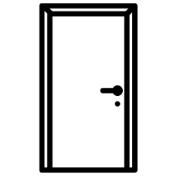 | Privacy  When you are sharing a home, it is important to respect each other’s private time and space.  - When in your room, toilet and bathroom remember to keep the door closed and if there is a lock please use it.  - Knock before you enter a room, especially any private use areas (bedrooms and bathrooms).
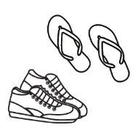 | Shoes inside the house  - Ask your host if shoes can be worn in the house.  - Please do not wear high-heel shoes on polished floorboards.  - Try to avoid wearing shoes on the carpet.
House Key
Your host will provide you with your own house key when you arrive. If you lose the key you may be charged for the cost of a replacement key. The key is to be returned to your host before you move out. When leaving the house daily, please ensure that you:
- Turn off lights, fans, air conditioning, heating, laptops, etc. at the wall or power board switch in your room
- Lock the outside door and close any windows.
- Other: _____________________________________________________
- Other: _____________________________________________________
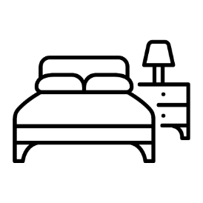 | Your Room  - In Australia, we sleep in a bed, between the sheets, with blankets on top.  - Ask your host about changing bed sheets, pillow cases and towels. This will be done at least once every two weeks.  We ask you to please;  - Keep your room clean and tidy.  - Do not cook, or keep food in your room.  - Do not leave any wet clothing or towels in your room.  - Do not stick anything to the walls. If you wish to hang anything, see your host.  - Ask your homestay family if you need extra blankets if you are cold or a fan if you are hot.
Noise
- Your host won’t mind you playing music or chatting with your friends via mobile or internet but please try to do this before 10:30pm at night.
- If you need to call your family after this time due to time zone differences, please check if this is ok with your host first.
- Always try to keep the noise level at a point where it doesn’t upset other family members or their sleep.
Internet
- Ask your host how the internet works in their home.
- Ask your host how this works in their home. The internet is for study purposes. Please be mindful of internet usage when it comes to gaming and entertainment.
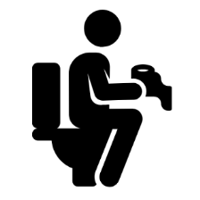 | Toilet  - Never squat or stand on the toilet seat.  - Never flush anything down the toilet except for toilet paper.  - Don’t use too much toilet paper as it may block or cause the toilet to overflow.  - Always wash your hands with soap after using the toilet.  - Please wipe down any spills on the toilet after you’ve finished.  Women/Girls  - All sanitary items such as tampons and pads should never be flushed down the toilet.  - At home, there will be a bin in the toilet or bathroom area or you may need to ask your host mother where to dispose of sanitary items.  - If you are still unsure, wrap the sanitary item in toilet paper and put in a plastic bag and then put it in the garbage bin outside.
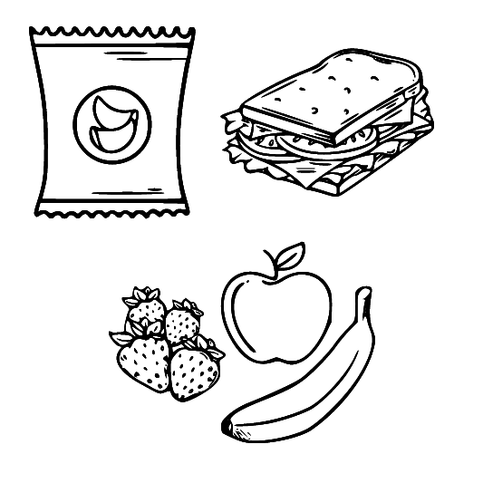 | Meals  Students have different meal options with their homestay. Your host or AHN can show you which meal option you have chosen (check your invoice or placement report). The information below should be used as a guide if your package includes meals.  - Breakfast: Let your host know what you want and you can help yourself e.g. cereal, toast, fruit, juice, tea or coffee. Australians normally have a cold breakfast.  - Lunch: This could include sandwiches, salads, fruit or muesli bars but may also be noodles or a hot meal. ‘Leftovers’ is food cooked the night before and put into containers in the fridge that you can then heat up again at your Education Provider.  - Dinner: Can be hot or cold. Discuss with your host what food you don’t like so this can be considered when they make their family meal. Dinner is normally served early in the evening in Australia. Ask your host what time they usually eat. It is polite to let your hosts know by 4:00pm if you will not be home for dinner or will be late so that food is not wasted.  When you use the kitchen please make sure that you leave the kitchen clean and tidy. Under 18's are not allowed to cook on their own and must ask permission before using the kitchen, this is not allowed in all homestays.
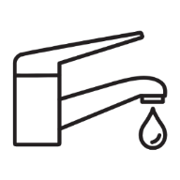 | Water Usage – Water Restrictions  - In Australia water is expensive and its use is restricted in some areas.  - Please help us save water by keeping showers to a 5-10 minute limit and turning off the water whilst you brush your teeth.  - Please do not waste water. Ask your host family about other ways to save water.
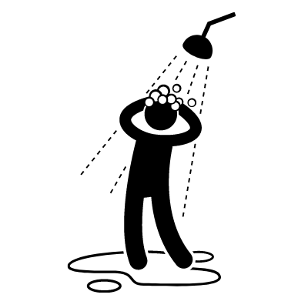 | Bathroom  - Please only bathe in the bath or shower cubicle so water does not splash onto the bathroom floor.  - When using the bathroom, close the door. There may be a privacy lock on the door, please use it.  - There is usually a bath mat on the floor. Stand on that when you get out of the shower so you do not slip over.  - Hang your towel up to dry after you use it. Check with your host family where you should hang your wet towel.  - Have a toiletry bag with your own shampoo, soap, tissues, etc.  - Leave any wet items in the bathroom or hang out to dry – please do not leave them in your room.  - If you make a mess, please clean it up.  - Please complete all shower activities by 10:00pm. If you need to shower later for some reason, please chat to your host.
Personal Hygiene
Remember that Australia can have very warm weather; students should maintain good personal hygiene by putting on deodorant each morning before dressing.
Lights, Fans and Heating
- Please make sure you turn off all lights when you go to sleep (ask your host for a small wall light if needed).
- Please turn off fans/air conditioning and heating in your bedroom when you are not home.
Laundry
Ask your host family about washing your clothes. Your host family may want you to:
- Do your own washing – your host will instruct you on how the machine operates and how much detergent to use. Full loads only please. Only perform 2 washes per week due to water restrictions. Once the washing is done, hang it on the clothesline.
- Some host may ask you to put your laundry items in a basket provided and your host will wash them for you.
- Ask your host if you would like to hang your underwear to dry in a private place.
- Your host will advise you what day you need to change the sheets on your bed and when to change your towels.
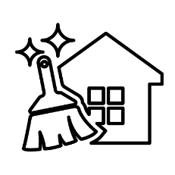 | Cleaning  Cleaning is part of family life and you may be asked to help out.  - Help with tidying up after meals, including washing or drying dishes.  - Keep your own room clean and tidy and make your bed.  - Keep your bathroom clean and tidy – do not leave wet towels and clothes on the floor.  - If you make a mess anywhere in the home, please clean it up. If you are unsure what to use, chat to your host and they will help.
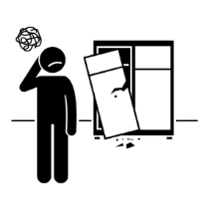 | Broken or damaged something in the house?  - Don’t worry, accidents can happen sometimes.  - Please let your host know if something has been broken or damaged.  - AHN students and hosts have some insurance coverage. Give AHN a call or email if you have any questions.
Smoking and Alcohol (not permitted for students under the age of 18 years old)
Do not smoke in the house –
- If you are over 18 and your host allows smoking at the house, you can only smoke outside and use the container provided for the butts.
- You cannot smoke inside the host’s home. Please ask if you have any problems or questions.
Be sensible with alcohol –
- If you are over 18 and your host allows alcohol at the house, be sure to drink responsibly and behave in a respectful manner.
- Remember that excessive drinking can have a negative impact on your studies and your personal life.
Friends
- If you wish to have friends visit you at your homestay, please ask your host for permission before you invite them over.
- It may not be permitted to have friends visit or sleep overnight.
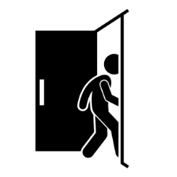 | Going Out  - If you are under 18, you must advise your host where you are going and when you will be home prior to going out at night. You need to be home by the curfew set by your welfare provider and/or host.  - Students under 18 years of age are not permitted to stay away from the homestay overnight without written permission from their college guardian.  - If you go out with friends at night or on weekends you must find your own way home either by public transport or taxi. Travel with friends especially at night!
Public Transport
- Download the local transport app on your phone and computer to work out the best and quickest route to travel.
- Ask your host and college about a transport card as this is cheaper than buying a paper ticket when using public transport. You must carry your valid student ID card to receive a concession or you may be fined a fee by the Transport department inspector.
Follow AHN Policies
- All homestay participants – Guests and Hosts – must abide by AHN policies through a placement.
- Public policies can be found at https://au.homestaynetwork.org/policies.
Intending to leave Homestay?

You are required to give AHN and your Host family two weeks’ notice in writing. Send AHN a message through the system or email your local office if you wish to give notice.

You are not permitted to enter into a private arrangement with your host.

Other House Rules
- __________________________________________________________
__________________________________________________________
__________________________________________________________
- __________________________________________________________
__________________________________________________________
__________________________________________________________
- __________________________________________________________
__________________________________________________________
__________________________________________________________
- __________________________________________________________
__________________________________________________________
__________________________________________________________
- __________________________________________________________
__________________________________________________________
__________________________________________________________
- __________________________________________________________
__________________________________________________________
_________________________________________________________
- __________________________________________________________
__________________________________________________________
__________________________________________________________

